

z

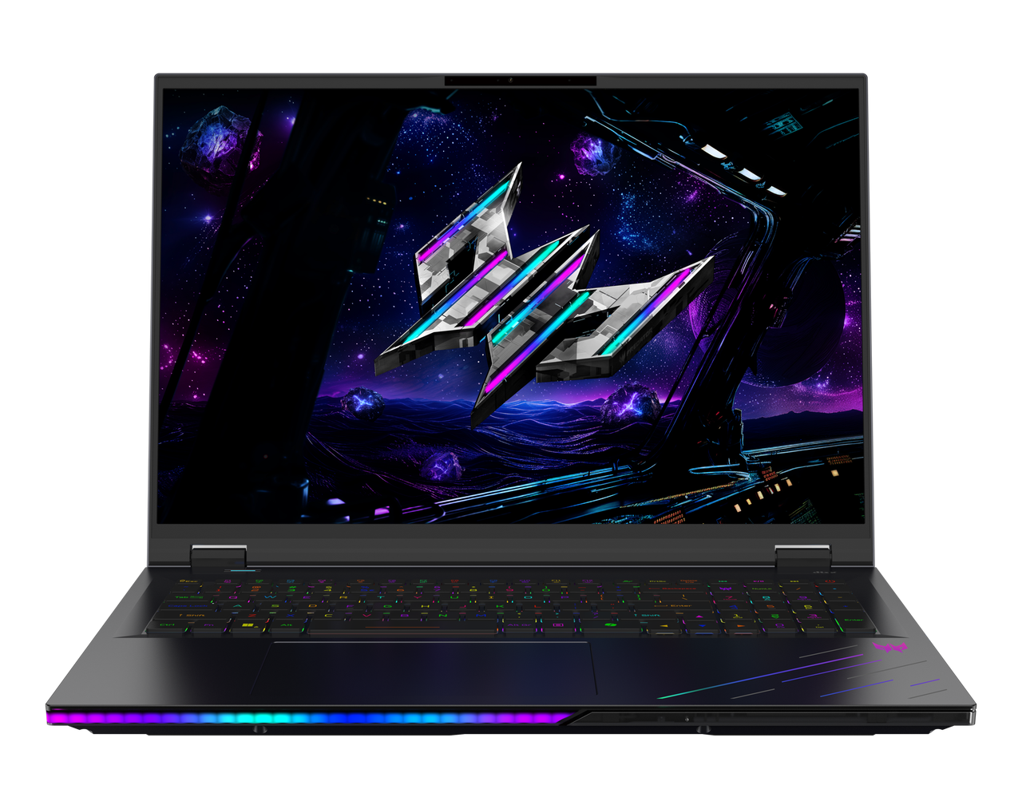

PREDATOR HELIOS NEO 16 AI

SPECIFICATIONS PREDATOR HELIOS NEO 16 AI PHN16-I71

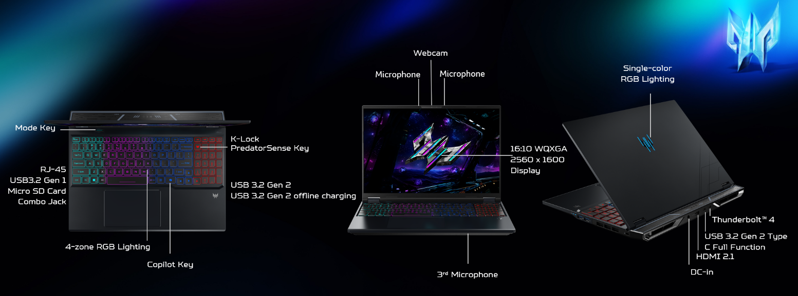
Operating System |  | Windows 11 Home
CPU and Chipset |  | Intel® Core™ Ultra 9 processor 290HX Plus  Intel® Core™ Ultra 7 processor 270HX Plus
Memory |  | Dual-channel DDR5 SDRAM support  Up to 64 GB of DDR5 system memory using four soDIMM modules | Memory Frequency : Up to 6400 MT/s
Display |  | 16.0" display with OLED (Organic Light-Emitting Diode) technology | WQXGA 2560 x 1600 | 500 nits brightness, typical | Acer CineCrystal™ | 165 Hz refresh rate | VESA DisplayHDR™ True Black 500 certified | NVIDIA® Advanced Optimus capable  16:10 aspect ratio  100% DCI-P3 color gamut, typical  Peak brightness up to 500 nits in HDR  Wide viewing angle up to 178 degrees  Mercury free, environment friendly | 16.0" display with IPS (In-Plane Switching) technology | WQXGA 2560 x 1600 | 500 nits brightness | Acer ComfyView™ LED-backlit TFT LCD | 240 Hz refresh rate | 3 ms G to G response time with overdrive  16:10 aspect ratio  100% DCI-P3 color gamut  Wide viewing angle up to 170 degrees  Ultra-slim design  Mercury free, environment friendly |  | 16.0" display with IPS (In-Plane Switching) technology | WQXGA 2560 x 1600 | Acer ComfyView™ LED-backlit TFT LCD | 180 Hz refresh rate | 3 ms G to G response time with overdrive | NVIDIA® Advanced Optimus capable  16:10 aspect ratio  100% sRGB color gamut, typical  Wide viewing angle up to 170 degrees  Ultra-slim design  Mercury free, environment friendly
Graphics |  | NVIDIA® GeForce RTX™ 5080 16 GB GDDR7  NVIDIA® GeForce RTX™ 5070 Ti 12 GB GDDR7  NVIDIA® GeForce RTX™ 5070 Ti 8 GB GDDR7  NVIDIA® GeForce RTX™ 5060 Ti 8 GB GDDR7
Audio |  | Quad + Dual Speakers output with smart amplifier enhancement and Acer TrueHarmony technology for lower distortion, wider frequency range, headphone-like audio, and powerful sound | DTS® X: Ultra Audio featuring optimized bass, loudness, and speaker protection with up to 6 custom content modes powered by smart amplifier |  | Immersive audio rendering over headphones and internal speakers  Acer Purified Voice technology with AI noise reduction using a 3-microphone array to support Advanced
 |  | Active-forced vibration cancellation dual speaker module design to enhance speaker performance and reduce system resonance | Supported in Windows Spatial Sound for PC Gaming with DTS Sound Unbound license integrated |  | High SNR DAC with 2.1 Vrms output capability, capable of driving high impedance headphones up to 600 ohms
Storage |  | Solid state drive: (2 slots): 512 GB / 1 TB / 2 TB, PCIe Gen4, 16 Gb/s, NVMe
Webcam |  | Video Conferencing  UFC with narrow USB FHD camera and IR camera | Blue glass lens | 1920 x 1080 resolution | 1080p video with temporal noise reduction | Staggered high dynamic range (SHDR) | Dual microphones 33 mm + 33 mm | 88 x 3.2 x 2.6 mm | Windows compatible only
Wireless and Networking |  | WLAN:  Killer™ Wireless Wi-Fi 6E 1675i  802.11 a/b/g/n/ac/ax wireless LAN  Band: 2.4 GHz, 5 GHz and 6 GHz  2x2 MU-MIMO technology  Support CNVi interface | LAN:  Killer™ Ethernet E3100G  2.5G Ethernet  Killer Control Center  Lag and Latency Reduction™ Technology  Advanced Stream Detect™2.0  Killer DoubleShot™ Pro enabled  GameFast™ Technology |  | WPAN:  Supports Bluetooth® 5.4 or above  Supports Bluetooth LE Audio (LC3)
Security |  | Firmware Trusted Platform Module (TPM) solution | BIOS user, supervisor passwords | Kensington lock slot
Dimensions and Weight |  | Dimensions  356.78 (W) x 275.5 (D) x 13.47/26.75 (H) mm (14.05 x 10.85 x 0.53/1.05 inches) with RTX 5070 Ti/RTX 5080  356.78 (W) x 275.5 (D) x 13.47/23.90 (H) mm (14.05 x 10.85 x 0.53/0.94 inches) with RTX 5070/RTX5060 |  |  | Weight  2.7 kg (5.95 lbs.) with 4-cell battery pack
Power Adapter and Battery |  | Power Adapter  3-pin 330 W 5.5 PHY PCR 50% AC adapter  185.0 (W) x 85.0 (D) x 31.0 (H) mm (7.28 x 3.35 x 1.22 inches)  19.5 V / 16.9 A as output power  900 g ± 10%, with 180 cm DC cable  Black color with Acer logo  Brick - type AC pins | Power Adapter  3-pin 230 W 5.5 PHY PCR 50% AC adapter  157.0 (W) x 85.5 (D) x 25.4 (H) mm (6.18 x 3.37 x 1.00 inches)  19.5 V / 11.8 A as output power  640 g ± 10%, with 180 cm DC cable  Black color with Acer logo  Brick - type AC pinsBrick - type AC pins |  | Battery  92 Wh 4-cell Li-ion battery  For models with WQXGA Panel  Battery life:  Up to 5 hours (based on MobileMark® 2025 test results)  Up to 8 hours (based on video playback test results)
Input and Control |  | Keyboard  103 (US) / 104 (UK) / 107 (JP) keys | FineTip RGB-backlit keyboard | Independent numeric keypad | International language support  2.0 mm key travel  Programmable key | Acer My Key  Microsoft Copilot key  Dedicated PredatorSense key  Caps Lock indicator  Microphone mute indicator  Function Lock key on ESC | Touchpad  Multi-gesture touchpad | Two-finger scroll | Pinch gesture | Gestures to open Cortana | Action Center | Multitasking | Application commands  Microsoft Precision Touchpad certification  Moisture resistant |  | Control Keys  PredatorSense key  Microsoft Copilot key
Windows Desktop Apps |  | In-House Applications  Acer AlterView | LiveArt | Acer QuickPanel | Acer VisionArt | PredatorSense V5 (NB) |  | Tools  Acer My Key Application
Warranty |  | One-year International Travelers Warranty (ITW)
Disclaimers
• | Specifications vary depending on model.
• | Shared system memory may be allocated to support graphics, depending on system memory size and other factors. Actual system memory available to the operating system will be reduced by any memory used by the graphics solution and resources required by the operating environment.
• | Memory speed may vary, depending on the CPU, chipset or memory fitted.
• | All brands and product names mentioned herein include trademarks of their respective companies and are used solely to describe or identify the products.
• | 1 GB is 1 billion bytes. Actual formatted capacity is less and may vary depending on preloaded materials and operating environment. Acer Recovery Management uses a portion of the stated hard disk capacity as dedicated backup space.
• | Minor variations in system dimensions are possible due to the manufacturing process.
• | Weight may vary depending on product configuration, vendor components, manufacturing variability, and selected options.
• | Listed battery life is based on testing using video playback. The test clip loops and continues to run, without interruption or any other inputs, until the battery is drained. Stated battery life is for comparison purpose only. Actual battery life varies by model, configuration, applications, video chip format and features used. A battery's maximum capacity decreases with time and use. Battery life test configuration: 15th Gen Intel® Core U9 Refresh, NVIDIA® GeForce RTX™ 5060, WQXGA, SSD only, 64GB of DDR5 memory. Battery life test condition: LCD brightness 150 nits, connected headphones, WLAN off, Bluetooth off and Better Battery Mode on.
• | Actual battery life may vary considerably by specifications, depending on product model, configuration, applications, power management settings, operating conditions, and features utilized. Performance variation also arises based on components in use, which includes but is not limited to the processor, RAM capacity, storage, display and resolution, etc.
• | Bundled software may vary depending on hardware configuration, OS and regional availability.
Product sheet specification based on Predator PHN16-I71 Specifications (v3-0-3) (Preview)

